****UX Feedback Report**

***Vibe Check***

|  |
| --- |
| **Date : 05/01/2025** |
| **Version : 0.1** |
| **State : Finished** |
| **Author : Nuno Dias** |

#### Version history

|  |  |  |  |  |
| --- | --- | --- | --- | --- |
| **Version** | **Date** | **Author(s)** | **Changes** | **State** |
| 0.1 | 05/01/2025 | Nuno Dias | First Iteration | Finished |
|  |  |  |  |  |

Contents

1. Participants 4

1.1 Participant 1 4

1.2 Participant 2 4

2. Feedback 5

2.1 General Flow (Planned Flow) 5

2.2 Participant 1 5

2.3 Participant 2 5

2.4 Compiled Results 6

3. Improvements 7

3.1 Home Page 7

3.2 Registering 7

3.3 Main Feed 7

3.4 Searching 9

3.5 Interactive Design 9

3.6 Others 9

# Participants

## Participant 1

|  |  |
| --- | --- |
| Attribute | Details |
| Age Range | 50 |
| Gender | Male |
| Occupation | Policy Officer |
| Technical Expertise | Novice |
| Region | Belgium |
| Nationality | Portuguese |

## Participant 2

|  |  |
| --- | --- |
| Attribute | Details |
| Age Range | 49 |
| Gender | Female |
| Occupation | Unemployed |
| Technical Expertise | Zero |
| Region | Belgium |
| Nationality | Portuguese |

# Feedback

## General Flow (Planned Flow)

|  |  |
| --- | --- |
| Step | Description |
| 1 | Look at Home Page and try to Register & Login |
| 2 | Explore Main Feed page, interact with layout and complete some tasks:   * Like a post * Post a post * Search for the post |
| 3 | Explore other menu buttons:   * Account Page * Settings Page * Logout Button |
| 4 | Brief questionnaire about experience:   * Weak points (parts that felt unintuitive or unpleasant to use) * What are your prior experiences with this sort of applications? * Would you use this application? * What do you feel is lacking or holding you back from using this instead of other applications? |
| 5 | Brief questions on possible solutions (dependent on previous experience):   * Would ***X***be a good fix for this problem? * How would you feel about ***Y***? |

## Participant 1

Participant 1 had some prior experience with *X (previously known as Twitter)*, but only passively, and was quick to pick up on the intended flow. They registered quickly but commented on how there was no change to the page upon successful registering (they noticed the notification but expected a page change).

They then easily logged in and explored the main feed. Some functionality was explained as *WIP,* but they quickly found all the “common” functions they expected (liking, posting, searching, etc.). They expected the tags to be interactable, but they were not.

When using the search bar some problems arose. First, they did not read the tips and assumed that searching searched the post body. They also repeatedly clicked *Enter* when finishing the query which reloaded the page and cleared the search box.

They suggested some improvements to the search by adding a top tags/themes/vibes menu that would also fill up the empty space. They also complained about the lack of content (images, songs, videos, etc.). Additionally, they suggested a closed list of tags to create a more closed-knit community feeling. Something more personal as that is what they personally would like to see on other social media platforms.

They mentioned that they might use the app if it had the feeling they were looking for as they aren’t a fan of social media apps in general.

## Participant 2

Participant 2 had some prior experience with Instagram and Facebook mostly following accounts that inspire them. As such their experience and expectations were more in line with the *classical* social media experience. They also have some trouble with English and with technology in general which made their feedback more important regarding icons and intuitive design.

They had some trouble with the registering since the page doesn’t change and registered twice. The second request produced an error due to duplicate usernames. They logged in successfully and then explored the main feed. Although most icons and features were intuitive the + (plus icon) on the side was either missed or not clear enough and they failed to create a new post without a hint. The search bar also turned out to be a bit confusing.

They seemed less interested in using this app but still said they would (maybe due to personal bias). However, when they explained why they use current social media apps it seems obvious that they are also looking for a personal touch. They would like to follow their friends & people they know.

## Compiled Results

(Includes direct feedback as well as problems noticed by the supervisor, such as missed features and code related problems)

|  |  |
| --- | --- |
| Feature | Feedback |
| Home page | There was little to no exploration of the Home Page sub-menus, git repository links, getting started documentation and other links went unnoticed. |
| Registering | All participants seemed to lack positive feedback upon registering (mainly a redirection to a Login Page)  Supervisor noticed a lack of negative feedback as well |
| Main Feed | There was a lack of automated refreshing upon user interaction (liking and posting required a manual refresh)  There was also a lack of content (images, music, etc.) |
| Searching | There was a lack of intuitive design for searching the methods seemed a bit too advanced for a simple user just wanting to search for a topic. |
| Interactive Design | There was a lack of interactive design. Tags were not clickable and there were no clickable menus, perhaps to reliant on text and understanding instead of simple and easy clicks |
| Others | Most users wanted a more personal touch to the app. Following accounts they new as well as more isolated communities by interests (tags) |

# Improvements

## Home Page

* Visible Passwords

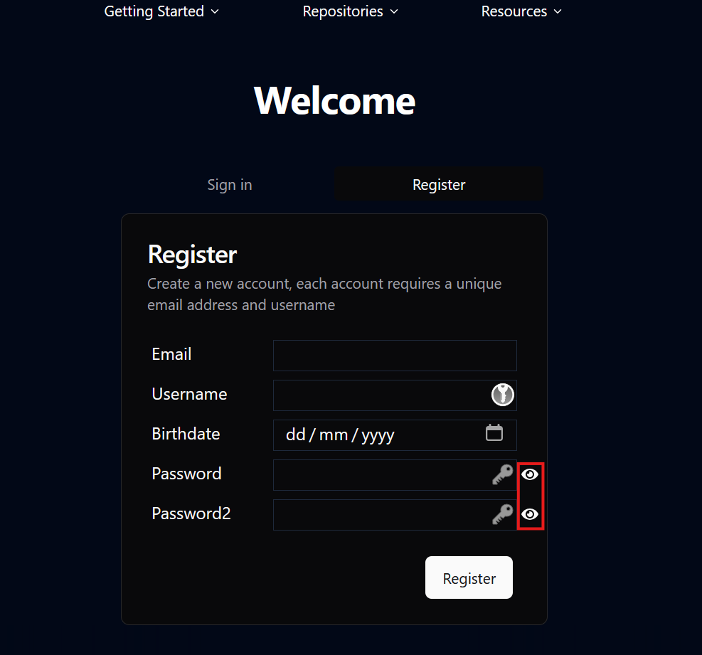

## Registering

* Automatic switch to Sign in tab upon registering

## Main Feed

* New Posts show up on top

* Liking gives feedback
* Clicking a tag searches for it

## Searching

* Search bar doesn’t refresh page

## Interactive Design

TBA

## Others

TBA